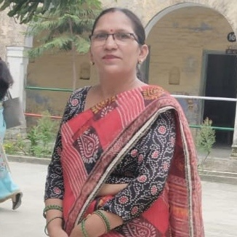
NAME :- Mrs. Geeta Bansal
DESIGNATION :- Lecturer
DEPARTMENT :- Sanskrit Department
STATUS :- Self Finance
E-MAIL ID :- geetabansal1111@gmail.com
QUALIFICATION :- M.A Sanskrit/ Hindi/ Education
DATE OF JOINING :- 12th September 2022
TOTAL EXPERIENCE :- 1 Year

